**Introduction to Programming EE2310 Homework 3**

**103061142 楊淳佑**

**Problem**

Write a program to generate a function and add a sinusoidal wave to it. Try to filter out the wave by using the way of recursive in the end.

**My Solution**

Use a for loop to calculate items in every number of columns one time. Loop again to calculate the next item.

**Additional Features**

None.

**Program Flow & Structure**

int main()

LINE

09~12

14~15

17~27

30

1. Define variables, open the target file.
2. Print out (also save to file) the column headings.
3. Close the target file.

for

1. Set s.
2. Calculate xo, x, xn, yo, y, yn respectively by using s and other variables.
3. Print s, xo, x to the screen.
4. Save all the variables above to the .csv file.

**Discussions**

* Is it necessary to use arrays to save the variables?

>> I don’t think so. Every time the program loop again, the value of the variables will still same as the value of the previous loop, on the same meaning as “n[i-1]”. Just assign 0 to every variables in the beginning of the program for the first time of the loop.

* Why is the graphic looked like this? Why are y[i] and yo[i] similar?

>> In the beginning, we add a sinusoidal wave to my own function (xo[i]). This makes the graphic of x[i] goes up and down when the graphic of xo[i] is still smooth. By using the technique of recursive, we can achieve the effect similar to **destructive interference**, and the wave that has been added the sinusoidal wave will be almost the same as the original one, that’s why the line of y[i] and yo[i] looks so similar.

**Output Result**

My own function: $3×\sqrt{s}$

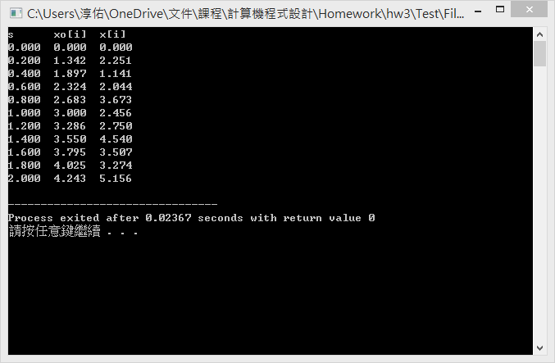

–

*p.s. Please check Result.csv in the homework folder for a more detailed result.*